Cloud Computing Intern
Internship Project Report

Serverless Weather Application using AWS Lambda, API Gateway, and S3

Abinaya K
Elevate Labs

October - November 2025

Mail – abinaya26kannan@gmail.com
Linkedin – www.linkedin.com/in/abinayak11
INDEX
S.NO | TITLE | PAGE NO
 | Abstract | 03
 | Objectives | 03
 | Technologies used | 03
 | System Architecture | 04
 | Implementation details | 05
 | Screenshots | 06
 | Challenges & Solutions | 09
 | Future Enhancements | 09
 | Conclusion | 09
 | References | 09

- Abstract
This project demonstrates the design and deployment of a serverless weather application using Amazon Web Services (AWS). The application integrates AWS Lambda, API Gateway, and OpenWeatherMap API to deliver real-time weather data. The frontend is hosted on Amazon S3 as a static website, styled with HTML, CSS, and JavaScript. The app dynamically updates weather conditions based on user input and adapts its background theme according to temperature. This project highlights cost-effective, scalable, and Free-Tier-friendly solutions for real-world applications.
- Objectives
- Build a weather app using serverless architecture.
- Practice integration of AWS Lambda with external APIs.
- Host a static frontend on Amazon S3.
- Ensure secure handling of API keys by keeping them in Lambda.
- Deliver a responsive, user-friendly interface with dynamic styling.
- Document the entire process for internship evaluation.
- Technologies Used:
Frontend: Html, CSS, JavaScript
Backend: AWS Lambda (Python 3.9)
API Management: AWS API Gateway
Hosting: Amazon S3 (Static Website Hosting)
External API: OpenWeatherMap
Styling: Google Fonts (Montserrat), dynamic CSS themes
- System Architecture
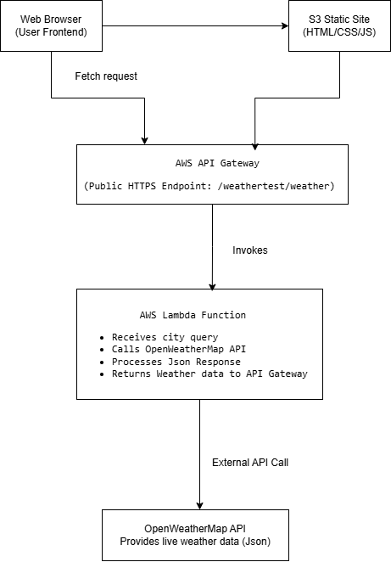

Explanation:
- Browser: User interacts with the app via search box.
- S3: Hosts static files (HTML, CSS, JS, images).
- API Gateway: Provides secure HTTPS endpoint.
- Lambda: Fetches weather data from OpenWeatherMap using API key.
- OpenWeatherMap: Supplies live weather JSON.
- Implementation Details
Backend (Lambda)
- Lambda function receives city query from API Gateway.
- Calls OpenWeatherMap API with stored API key.
- Returns JSON response to API Gateway.
API Gateway
- Configured with /weathertest/weather route.
- Handles CORS to allow browser requests.
- Integrates with Lambda via proxy.
Frontend
- HTML: Defines structure (search box, weather card).
- CSS: Styles app with warm/cool themes, brightened backgrounds.
- JS: Fetches weather data, updates DOM, applies dynamic background logic.
Hosting
- S3 bucket created with static website hosting enabled.
- Files uploaded: index.html, main.css, main.js, bg.jpg, cool-bg.jpg, default-bg.jpg.
- Bucket policy configured for public read access.
Features
- Search for any city’s weather.
- Dynamic background (warm vs cool).
- Default city (Chennai) loads on page open.
- Responsive UI with Montserrat font.
- Error handling for invalid inputs.
- Secure API key hidden in Lambda.

- Screenshots
  - AWS Lambda Function – Serverless backend logic
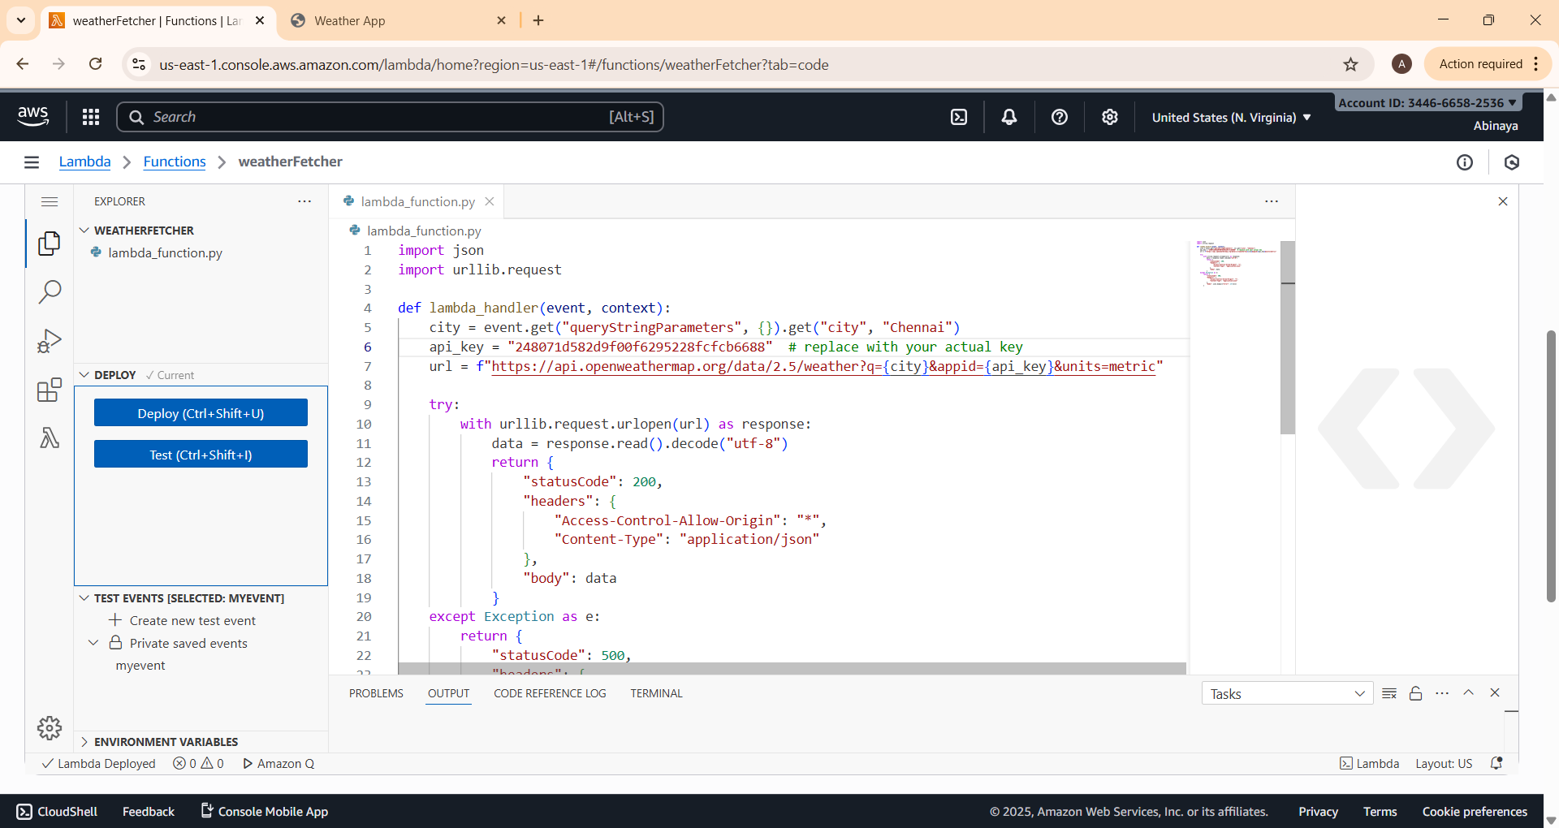
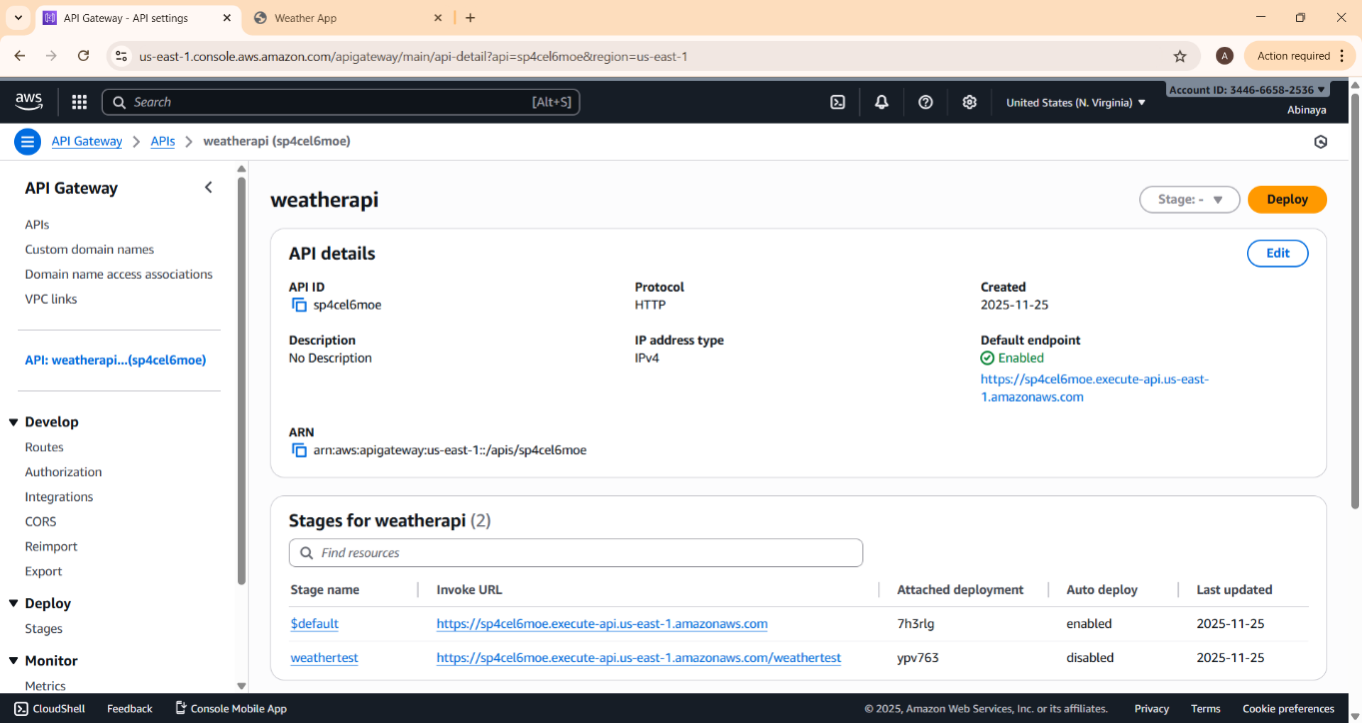

  - Amazon API Gateway – Secure API endpoint
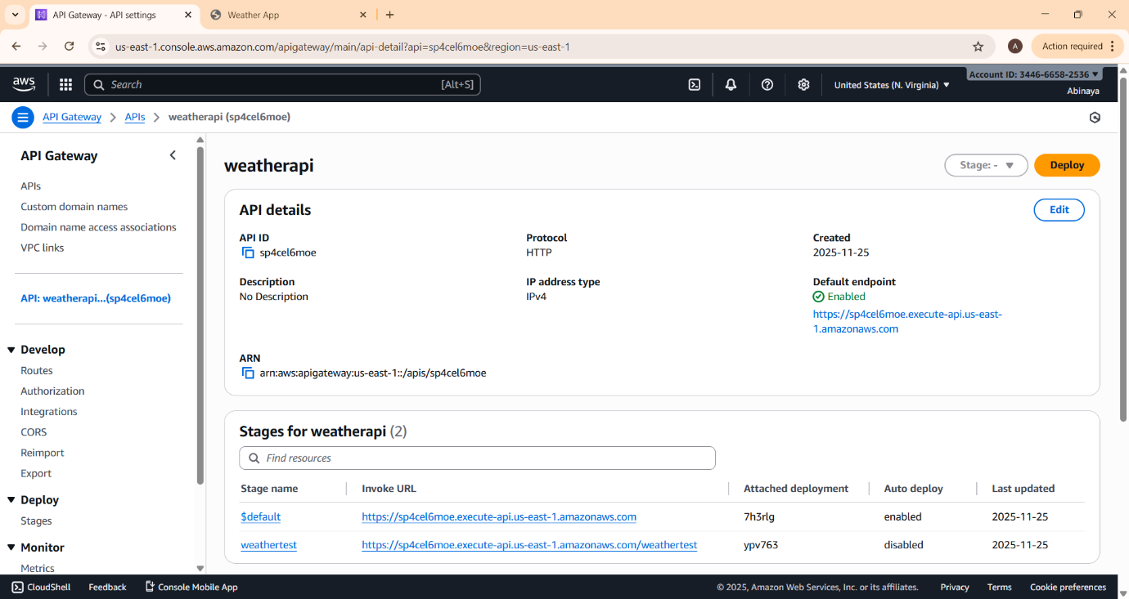
  - Amazon S3 Bucket – Static website hosting
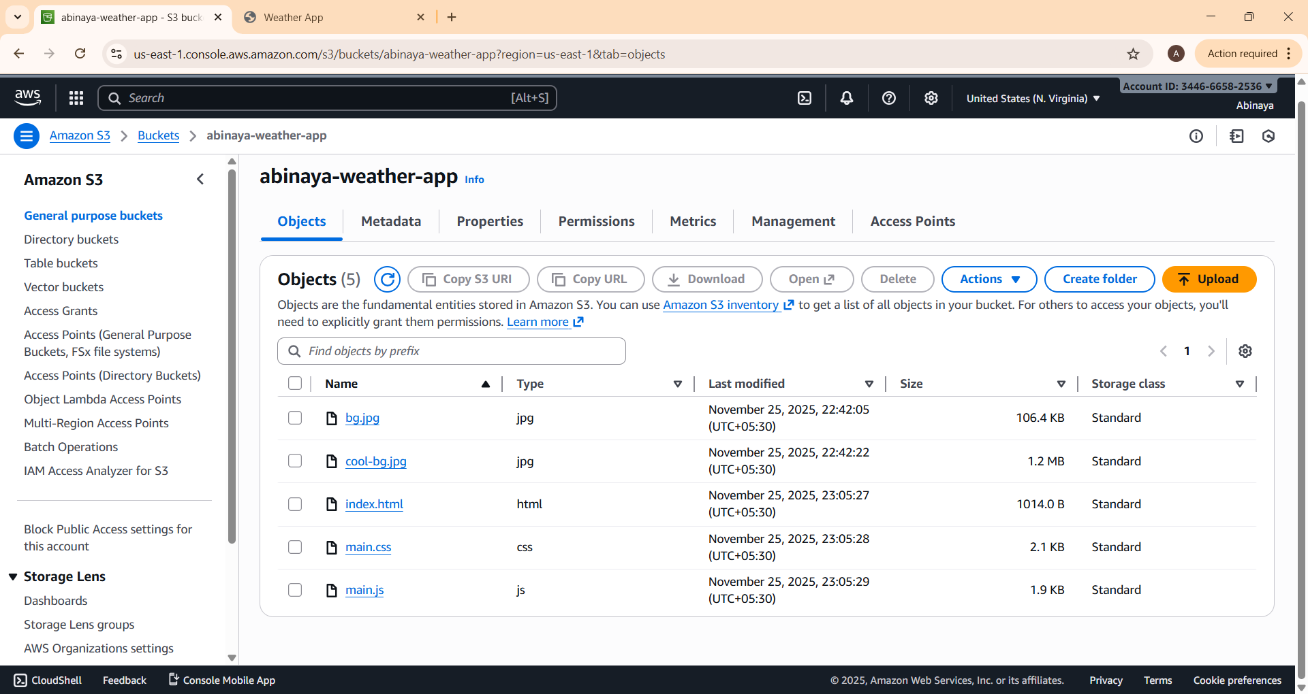

  - Weather App Output Screen – Frontend user interface
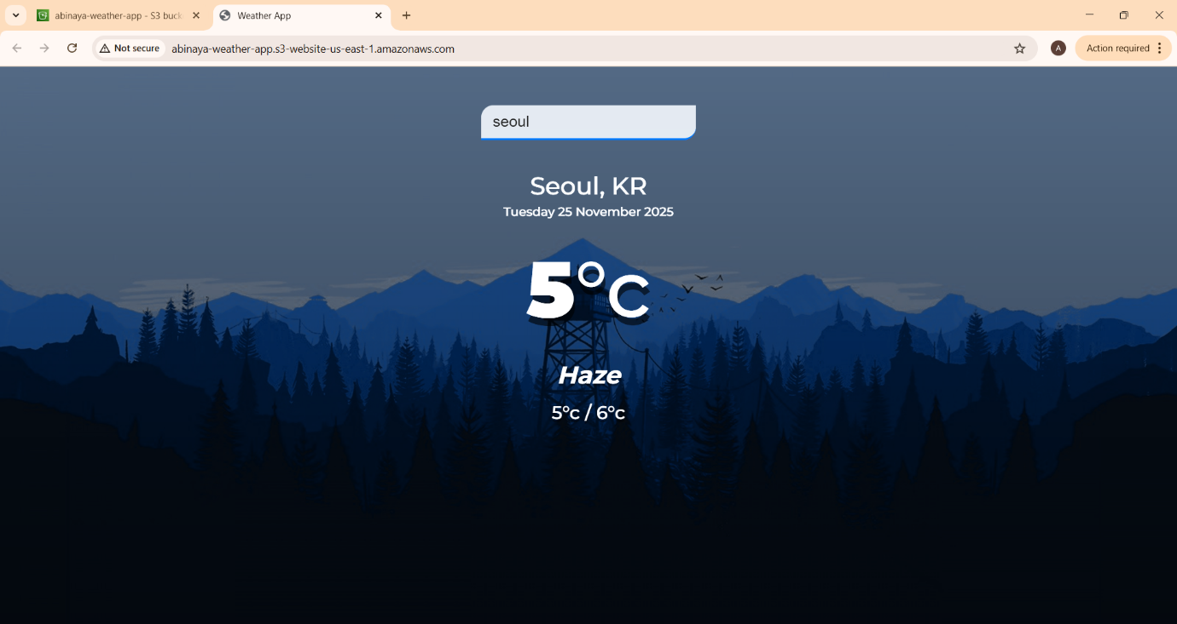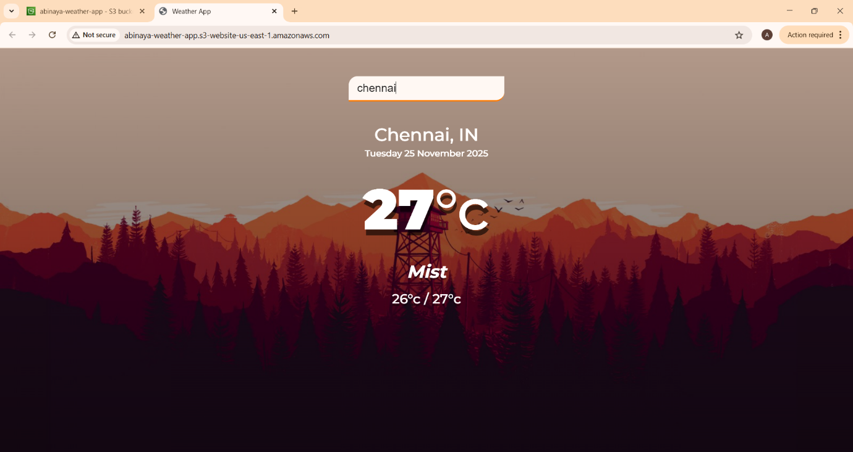

8. Challenges & Solutions
- CORS Issues: Solved by enabling CORS in API Gateway.
- Dull Background: Improved with CSS filters (brightness, contrast).
- API Key Security: Moved key to Lambda instead of frontend.
- Deployment Errors: Fixed by setting correct bucket policy and permissions.
9. Future Enhancements
- Add 5-day forecast view.
- Integrate CloudFront + HTTPS + custom domain.
- Mobile-friendly UI improvements.
- Localization (Tamil/English toggle).
- Add weather icons for conditions (sunny, mist, rain).
10. Conclusion
This project successfully demonstrates the use of AWS serverless architecture to build a scalable and cost-effective weather application. It highlights the importance of secure API integration, frontend-backend communication, and user experience design. Through this internship, I gained hands-on experience in AWS Lambda, API Gateway, and S3 hosting, as well as practical skills in frontend development and deployment.
11. References
- AWS Documentation: https://docs.aws.amazon.com
- OpenWeatherMap API Docs: https://openweathermap.org/api
- Tutorials - https://youtu.be/n4dtwWgRueI?si=Nr5lK9gZNGih0Fyo

